Artificial Intelligence in Taxation

[Table of Contents]

Business Process 1 2
1.1.1. Use Cases 3
1.1.2. Business Process Diagram (BPMN) 4
1.1.3. User Stories 5
Field Requirements / Business Rules 6
Wireframe 6
Test Cases 11

Business Process 1

Use Cases
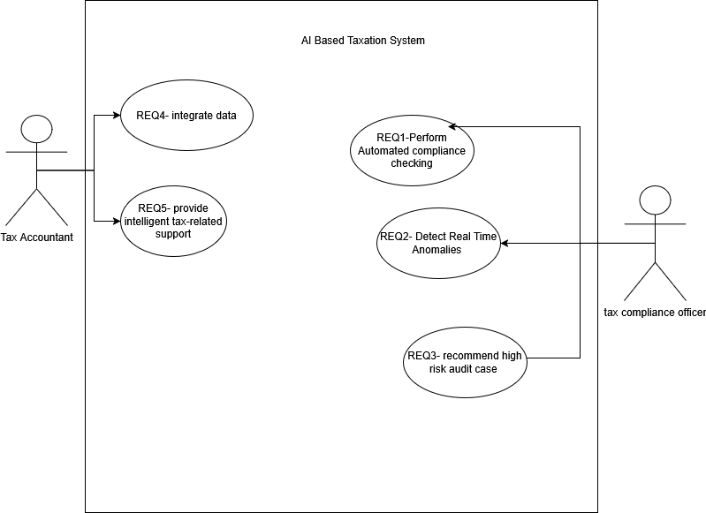

Business Process Diagram (BPMN)
BPMN for each user story requirement (REQ1-REQ5)

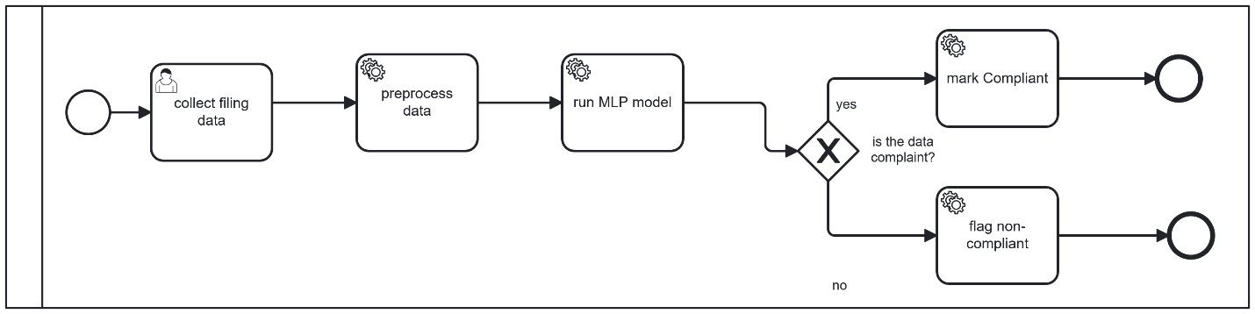
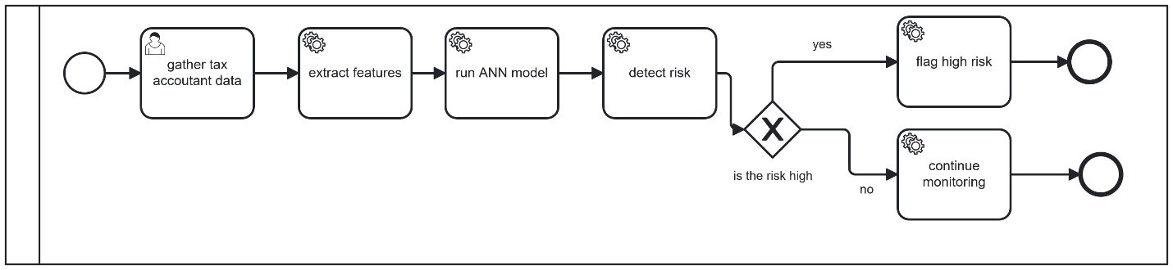
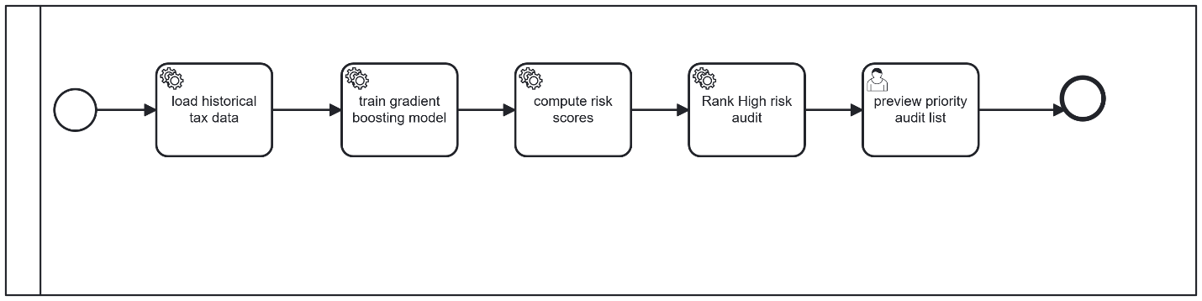

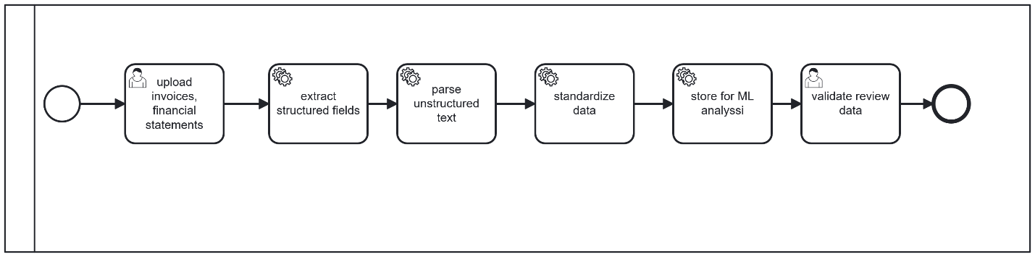
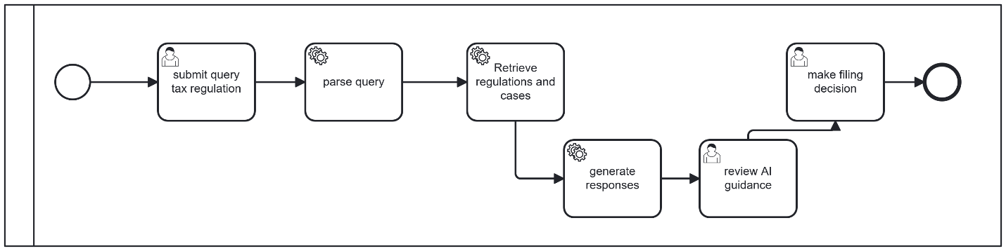

User Stories
[Create some user stories and split the business process into different epics to dive narrower into context]

Requirement ID | Epic | User Story Summary
REQ1 | AI- driven compliance monitoring | As a Tax Compliance Officer, I want to apply a Multilayer Perceptron (MLP) model for classification of tax filings in two classes: compliant or non-compliant, based on submission data, so that I can easily determine tax non-compliance and minimize the need for manual auditing.
REQ2 | Real time anomaly detection | As a Tax Compliance Officer, I want to apply an Artificial Neural Network (ANN) model for detection of fraudulent activities or suspicious activities by examining the taxpayer data, so that I can spot high-risk audit cases quickly.
REQ 3 | Predictive Audit Recommendation | As a tax compliance officer, I want the system to apply a Gradient Boosting machine learning algorithm trained on previous tax data like income and payment records to calculate tax audit risk scores and generate a prioritized list of high-risk cases so that allocate audit resources efficiently
REQ4 | Intelligent Data Integration & Processing | As a tax accountant, I want the system to utilize Robotic Process Automation (RPA) along with Natural Language Processing (NLP) technology to extract and integrate financial and tax data like invoices and financial statements so that the data is standardized and prepare it for machine learning.
REQ5 | AI-Powered Knowledge Support | As a tax accountant, I want the system to combine Natural Language Processing (NLP) with Retrieval Augmented Generation (RAG) technology to access relevant tax regulations and past case law so that I can make accurate tax filings decisions and reduce errors.

Field Requirements / Business Rules

REQ | Field | Description | Business Rule
REQ1 | Filing ID | Unique identifier for each tax filing | System-generated; read-  only; must be unique per filing

REQ1 | Taxpayer ID | Identifier linking the  filing to a taxpayer | Mandatory; must exist in  taxpayer registry
REQ1 | Income | Total declared income  of the taxpayer | Mandatory; must be > 0
REQ1 | Deductions | Total claimed deduc-  tions | Mandatory; must be ≥ 0  and cannot exceed Income
REQ1 | Tax Paid | Total tax amount paid  by taxpayer | Mandatory; must be ≥ 0
REQ1 | Status | MLP classification  output | System-assigned after clas-  sifier runs; read-only
REQ1 | Confidence | Model confidence per-  centage | Read-only; must be ≥ 80%  for reliable result
REQ1 | Action (Details) | Button to open filing  detail view | Only shown after classifica-  tion is complete
REQ1 | Classify Button | Triggers classifier on  pending filings | Only enabled for Pending  status filings
REQ2 | Name | Registered business or  individual name | Mandatory; read-only from  registry
REQ2 | Anomaly Score | ANN fraud likelihood  score | System-generated; value be-  tween 0 and 1; read-only
REQ2 | Risk Level | Fraud risk classifica-  tion | High: ≥ 0.70, Medium:  0.40–0.69, Low: < 0.40
REQ2 | Action (Analyze) | Trigger anomaly anal-  ysis | Enabled after scan comple-  tion

REQ2 | High Risk Cases | Count of high-risk  taxpayers | Auto-updated dashboard  metric
REQ2 | Medium Risk | Count of medium risk  taxpayers | Auto-updated dashboard  metric
REQ2 | Detection Rate | Model fraud detection  accuracy | Read-only performance  metric (percentage)
REQ3 | Priority | Audit urgency rank-  ing | Auto assigned; 1 = highest  priority
REQ3 | Audit ID | Unique audit identi-  fier | System-generated; read-  only
REQ3 | Taxpayer Name | Name of flagged tax-  payer | Pulled from registry; read-  only
REQ3 | Risk Score | Model risk score | System-generated; High  Priority if ≥ 70
REQ3 | Est. Recovery | Estimated recoverable  tax amount | Model-predicted; read-only
REQ3 | Recommended Action | Suggested audit ac-  tion | System-generated; read-  only
REQ3 | Details (View) | Opens full audit case  details | Always enabled
REQ3 | High Priority Cases | Count of high-risk au-  dit cases | Auto-calculated KPI
REQ3 | Avg Risk Score | Average risk score  across cases | Auto-calculated KPI

REQ3 | Est. Recovery (Total) | Total estimated recov-  ery amount | Auto-calculated KPI
REQ3 | Model Accuracy | Model performance  metric | Read-only percentage
REQ4 | Document ID | Unique document  identifier | Auto generated; must be  unique
REQ4 | Name (Document) | File name of uploaded  document | Captured from upload;  read-only
REQ4 | Type | Document classifica-  tion category | Auto detected by NLP
REQ4 | Upload Date | Date document was  uploaded | System-stamped; read-only
REQ4 | Status (Document) | Processing state of  document | Pending / Processing / Ex-  tracted
REQ4 | Action (View Data) | View extracted struc-  tured data | Enabled only if Status =  Extracted
REQ4 | Action (Process) | Trigger extraction  pipeline | Enabled only if Status =  Pending
REQ4 | Total Documents | Total documents in  system | Auto-incremented KPI
REQ4 | Processed | Successfully processed  documents | Auto-updated KPI
REQ4 | Processing | Currently processing  documents | Real-time KPI

REQ4 | Pending | Documents waiting  for processing | Auto-updated KPI
REQ5 | Search Query Field | NLP search input field | Mandatory; cannot be  empty
REQ5 | Search Button | Executes NLP search  pipeline | Disabled if query is empty
REQ5 | Sample Query Chips | Predefined query  shortcuts | Auto-fills and triggers  search
REQ5 | Search Results | Returned regulations  and cases | Populated after valid search
REQ5 | Regulation Reference | Source citation for re-  sult | Read-only reference link/-  text
REQ5 | Case Summary | Summary of similar  cases | NLP-generated; read-only
REQ5 | Relevance Score | Ranking score of re-  Sults | System-generated; used for  sorting
REQ5 | Empty State Message | Default prompt before  Search | Displayed when no query is  entered

Wireframe
https://www.figma.com/make/83KTX2wpi5L3GHVKl7067X/Prototype-User-Stories?t=m9UPHPH9mNIvDLtz-1
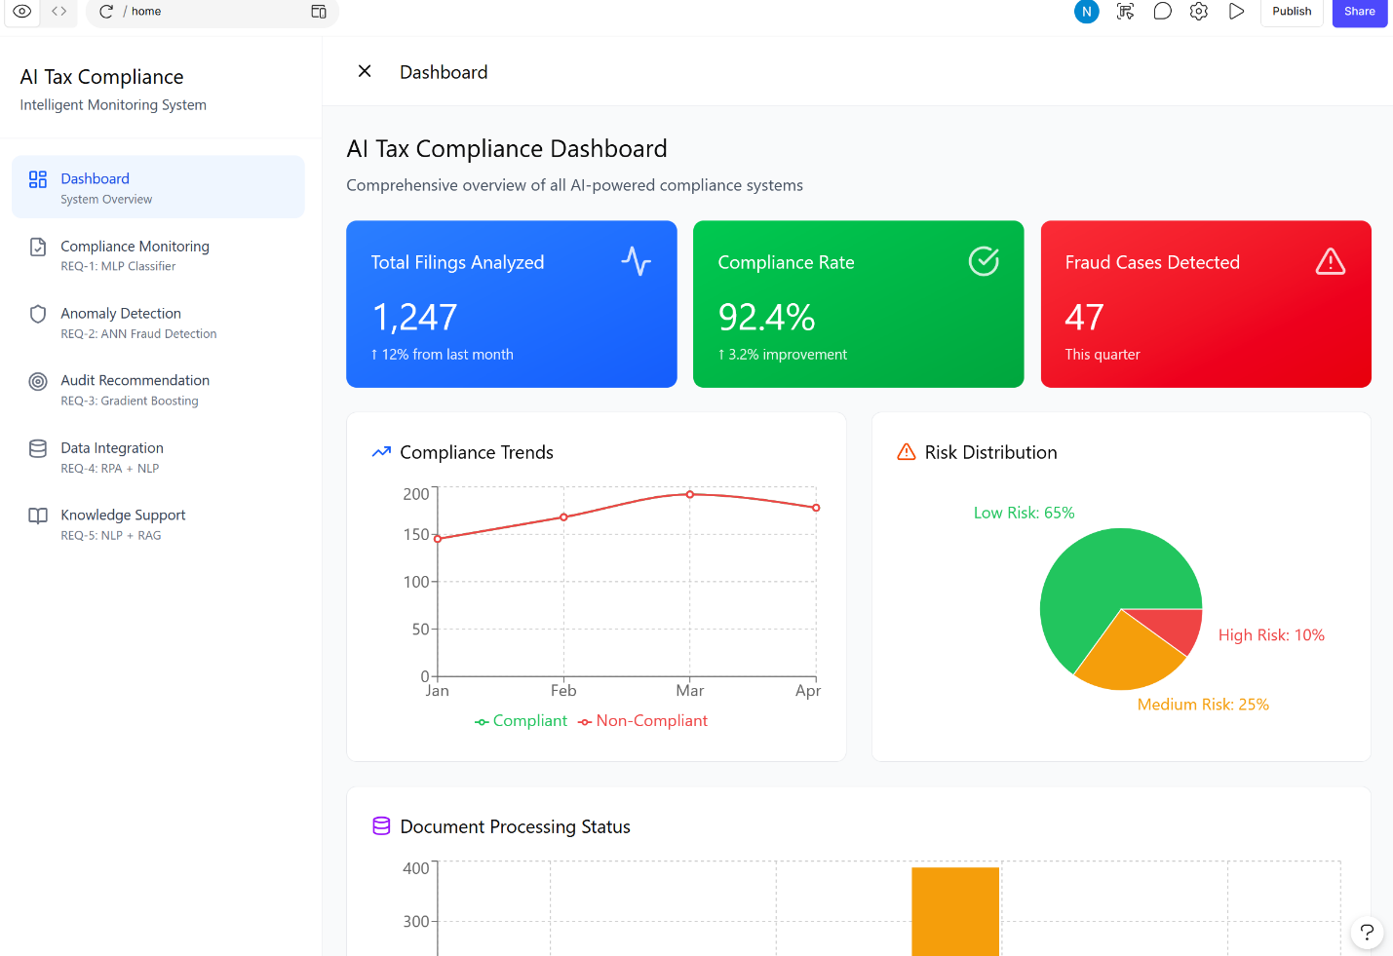
Figure 4Dashboard output

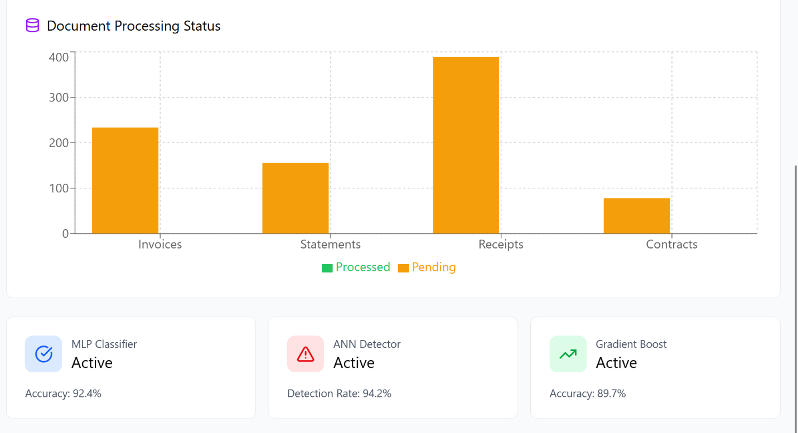
Figure 5Dashboard2 output screen
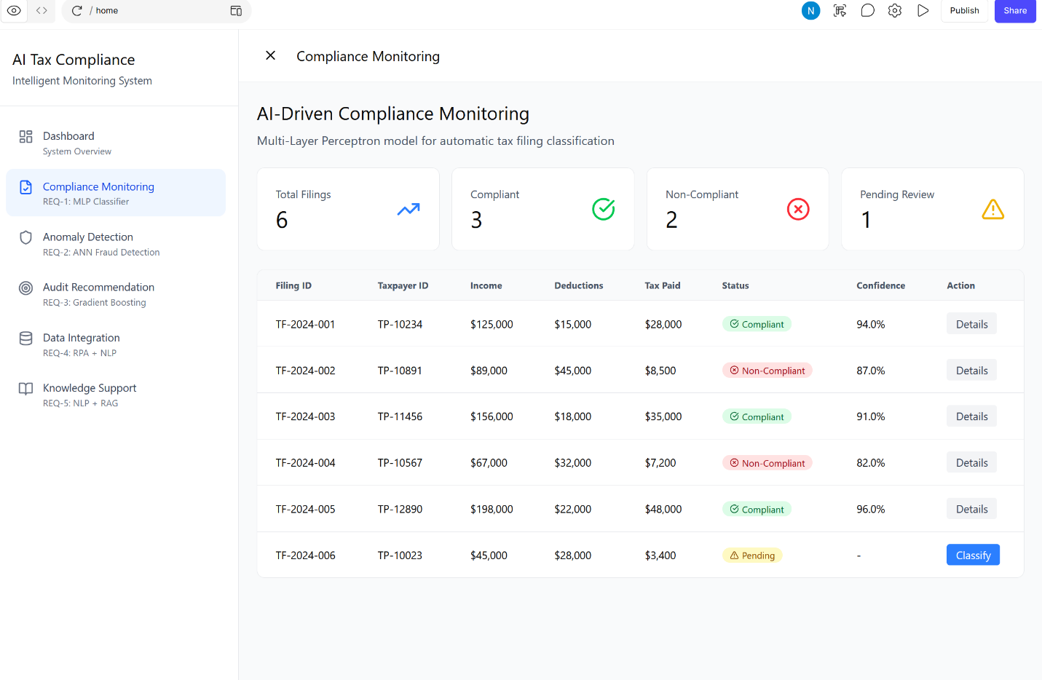
Figure 6Auto compliance REQ1 output screen
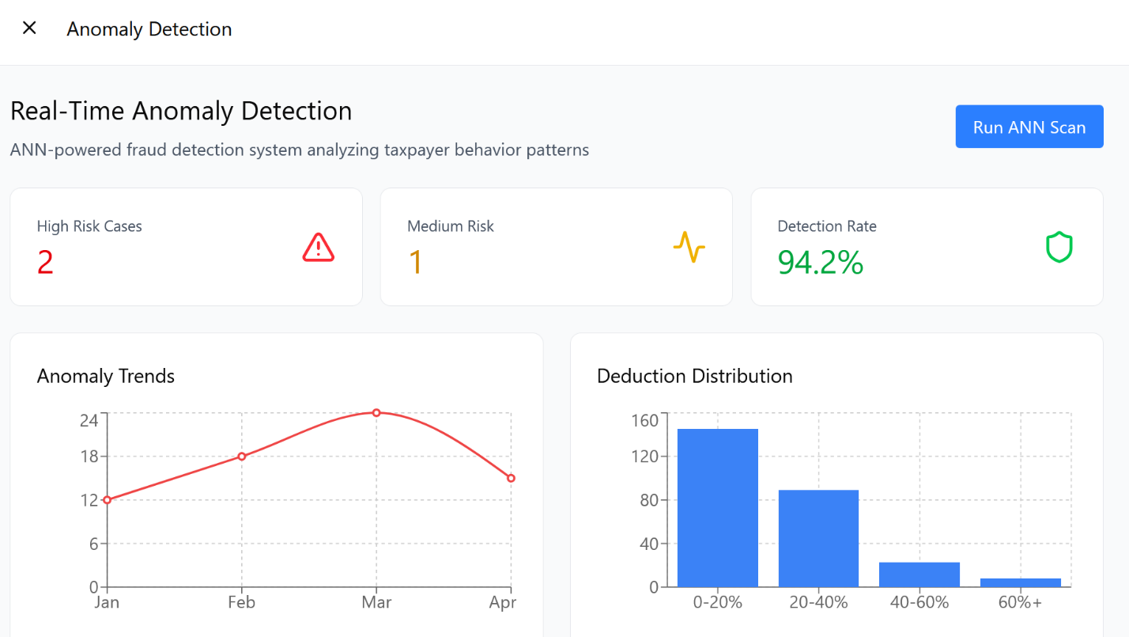
Figure 7 Anomaly detection REQ2 input-output screen
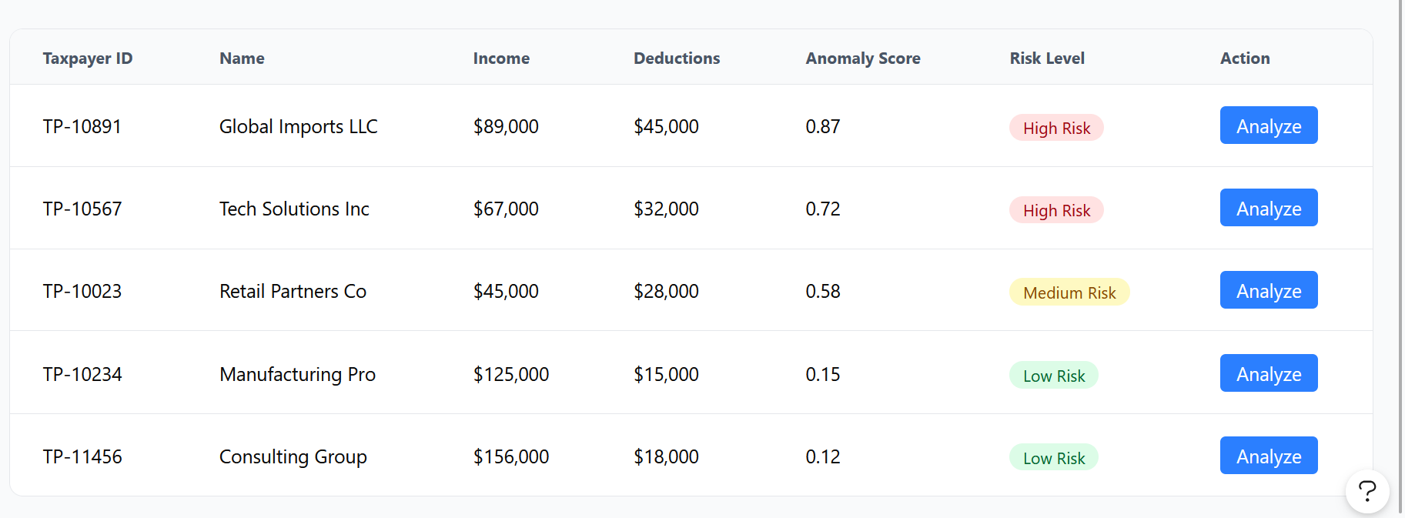
Figure 8 Anomaly detection2 REQ2 output screen
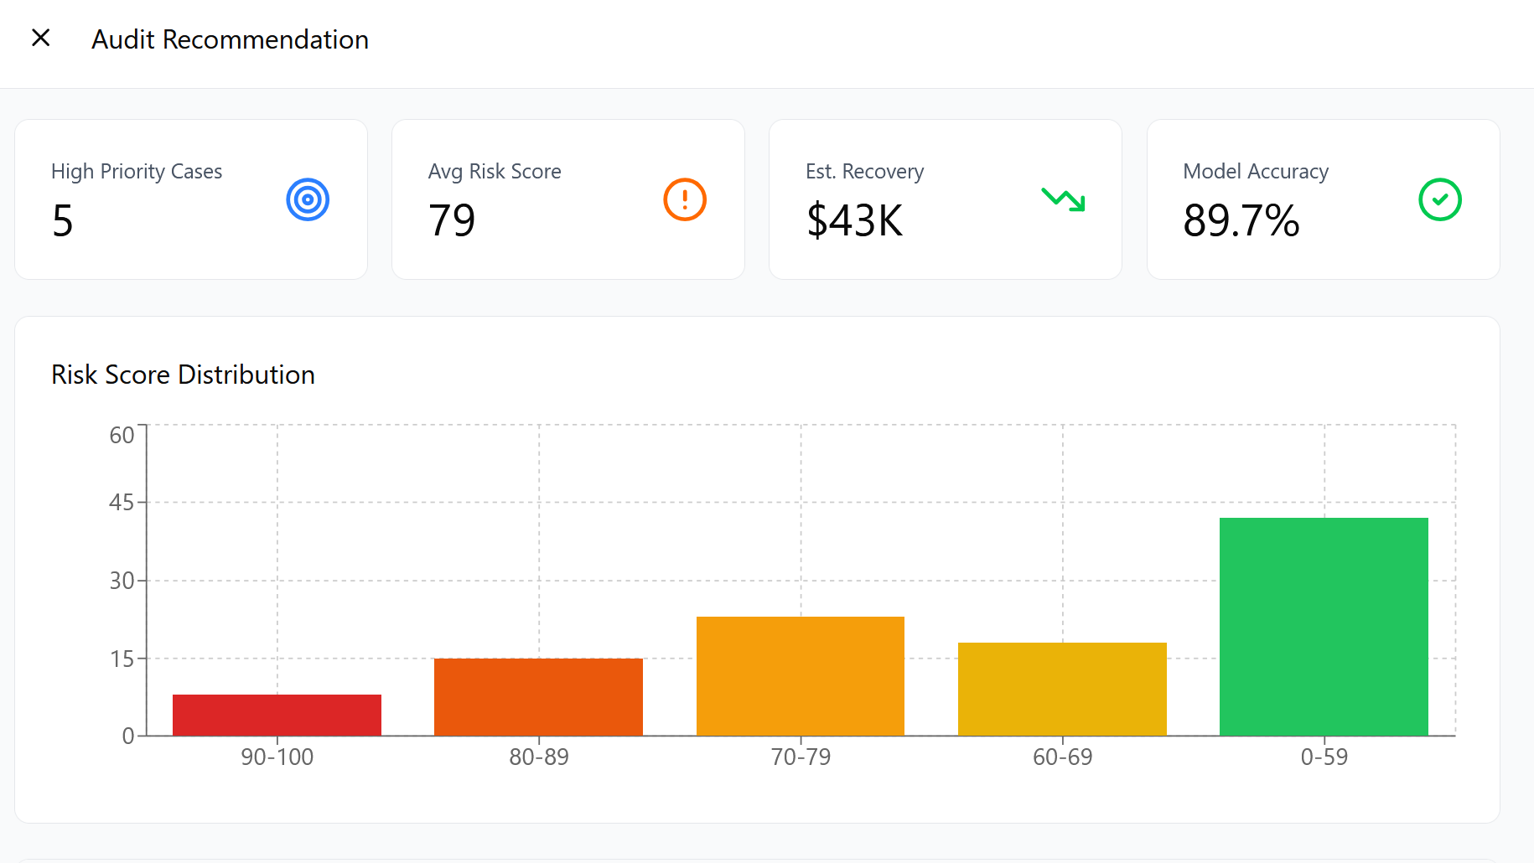
Figure 9 Audit recommendation REQ3 output screen
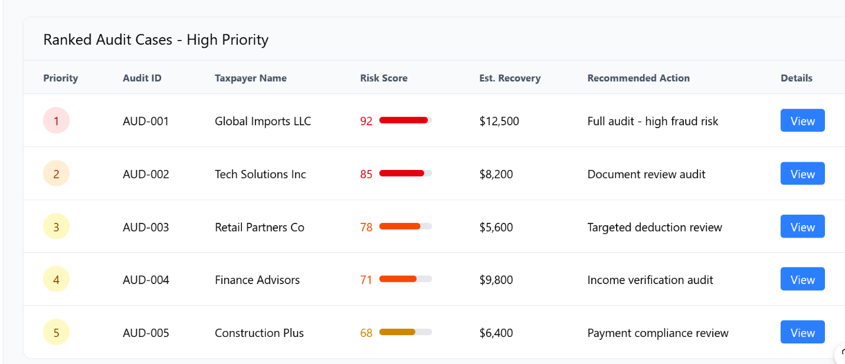
Figure 10 audit recommendation2 REQ3 output screen
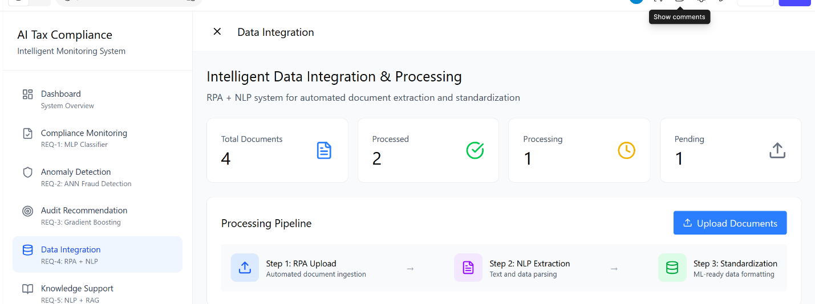
Figure 11 data integration REQ4 input-output screen
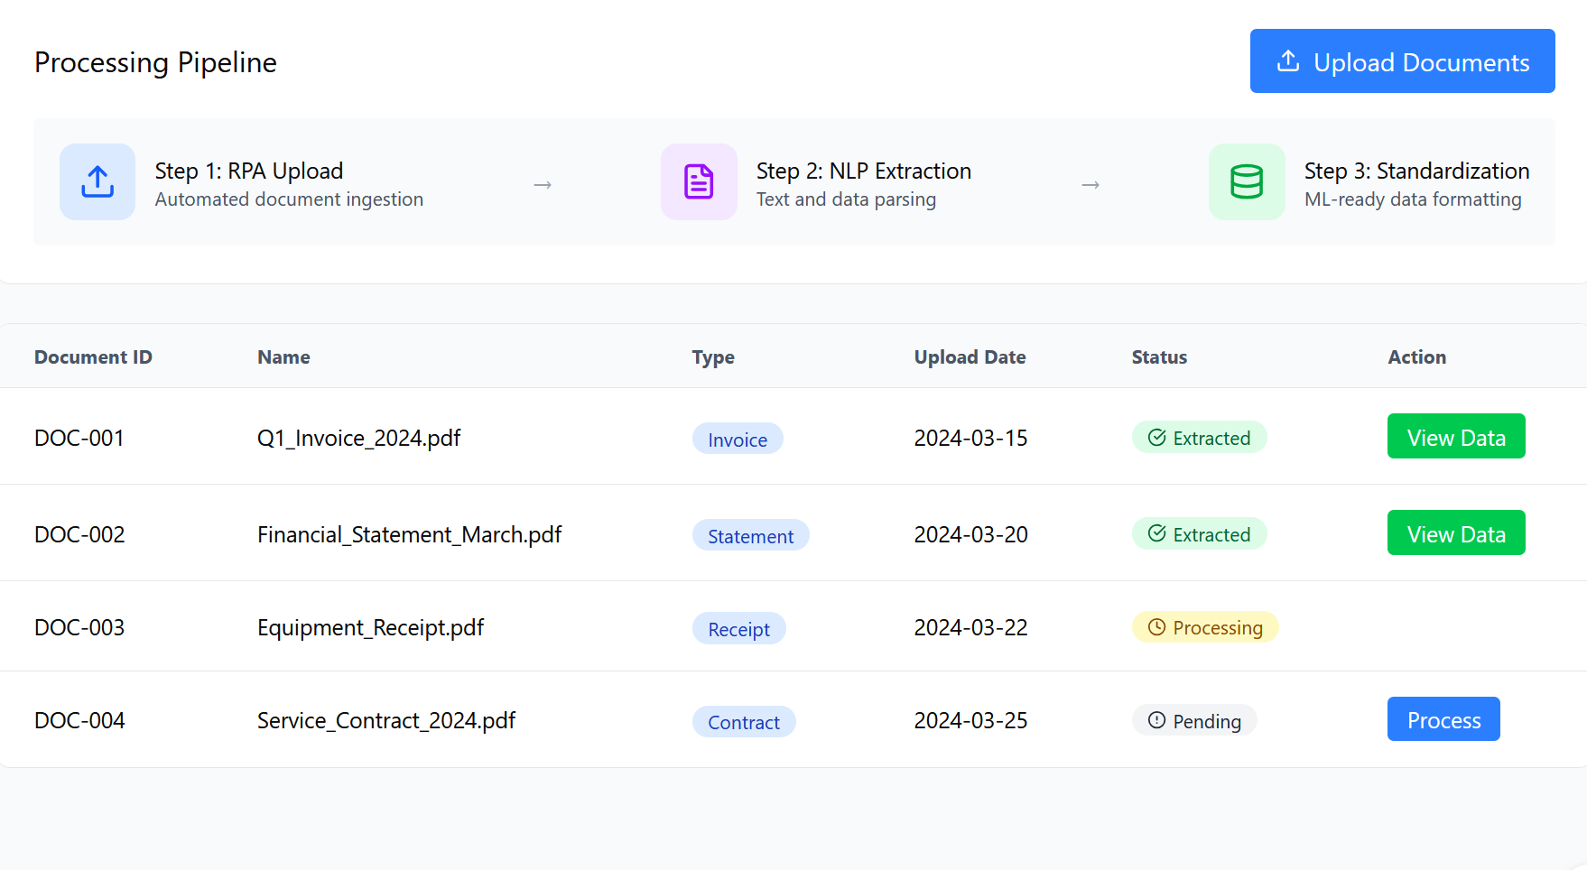
Figure 12 data integration REQ4 output screen
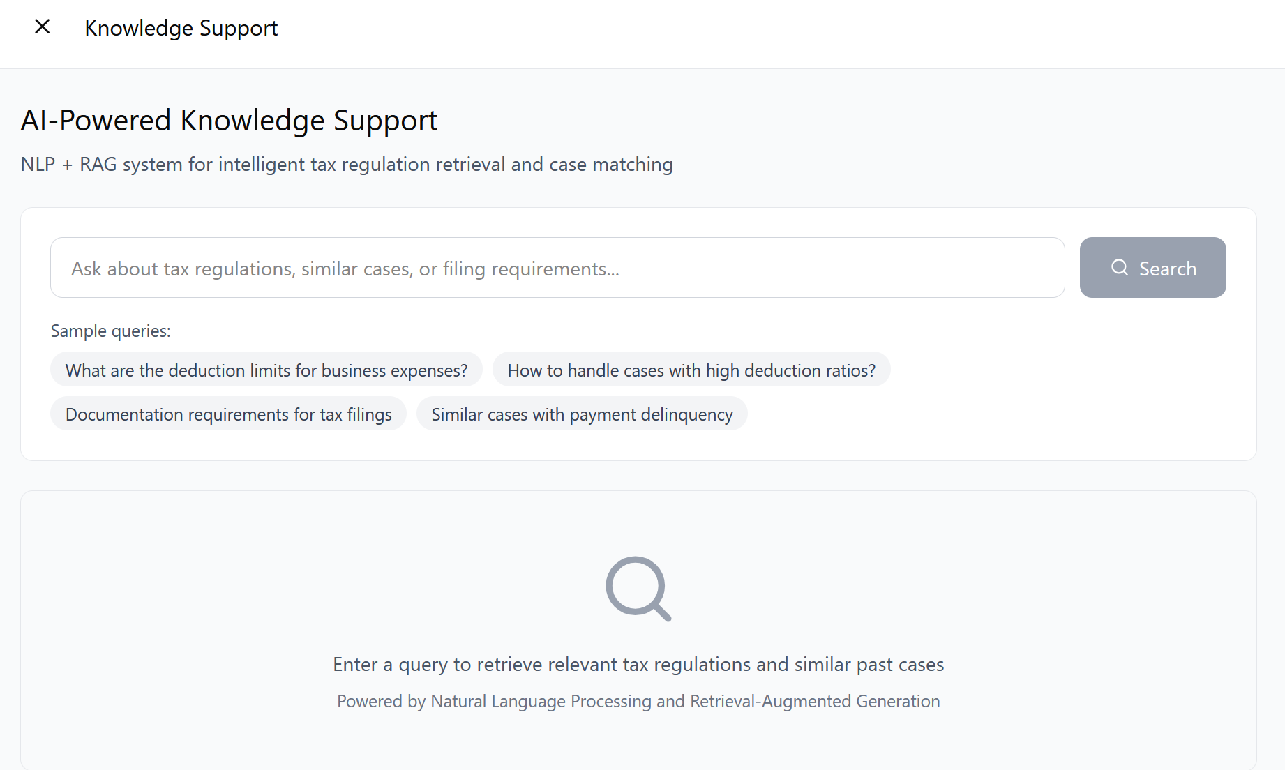
Figure 13 knowledge support REQ5 input-output screen

Test Cases

Test Case ID | Test Scenario | Test Steps | Expected Result
TC-1.1 | Identifying a compliant filing | 1. Go to Compliance Monitoring screen 2. Complete the tax filing with consistent data income deduction field along with other necessary details 3. Run MLP classifier 4. See the output of the classification | The system will show an output “Compliant” with probability ≥ 80%. The filing will not be marked for any manual check-up, and the compliance rate metric will go up.
TC-1.2 | Identifying a non-compliant filing | . Go to Compliance Monitoring page 2. complete the tax filing with inconsistent data in income and deduction field 3. Run MLP classifier 4. See the output of the classification | the system will display an output “Non-Compliant” and the case appears in the non-compliant list in the dashboard.
TC-1.3 | Submit filing with missing mandatory fields | Navigate to the Compliance Monitoring window 2. Enter a filing that has many mandatory fields missing 3. Try to invoke the MLP classifier | The submission fails due to an error that states there are missing fields The submission fails even before the classifier is invoked due to an error that states there are missing fields.
TC-1.4 | classify first time taxpayer filing | 1. go to Compliance Monitoring screen 2. Submit a filing of a taxpayer who has no record previously 3. Run the MLP classifier 4. Check the classification | The system will classify the entry without having any bias in the past since it considers only the current input data
TC-1.5 | Classification of several forms at once | - Access the Compliance Monitoring window 2. Import 100 tax forms together 3. Initiate batch MLP classification process 4. check system performance and results | The system manages to classify all forms accurately within the stipulated time frame. Every form is assigned with an appropriate classification code without any system errors.

Test Case ID | Test Scenario | Test Steps | Expected Result
TC-2.1 | ANN Scan on Taxpayer with High De duction Anomaly | 1. Go to Anomaly Detection 2. Ensure taxpayer details are loaded (e.g., Global Imports LLC: income $89K, deductions $45K) 3. Press “Run ANN Scan” 4. Check results | The system generates an anomaly score ≥ 0.70; risk status is “High Risk”. The Analyze option is available for this record
TC-2.2 | ANN Scan on Low-Risk Taxpayer | 1.Go to Anomaly Detection 2. Load taxpayer with low deduction-to-income ratio (e.g., Manufacturing Pro: income $125K, deductions $15K) 3. Press “Run ANN Scan” 4. Check results | The system generates an anomaly score ≤ 0.30; risk status is “Low Risk”. There is no suspicion of fraud
TC-2.3 | Check that High Risk Cases count is updated after scan | 1. Go to Anomaly Detection 2. Check the current number of “High Risk Cases” (for example, 2) 3. Perform ANN Scan with a new high-anomaly case 4. Check metrics | The number of “High Risk Cases” is incremented. The dashboard metrics (“Medium Risk”, “Detection Rate”) are updated accordingly.
TC-2.4 | Analyze a flagged high-risk taxpayer | 1.Go to Anomaly Detection 2. Find an item “High Risk” in the table 3. Click “Analyze” button 4. Check analysis details | The system provides detailed analysis regarding the selected taxpayer, specifically his/her income and deductions.
TC-2.5 | Update Anomaly Trends line chart over several months | 1. Access Anomaly Detection 2. Analyze Anomaly Trends line chart 3. Input additional scan data for new month 4. Examine the line chart | Anomaly Trends line chart gets updated by adding the latest data point without losing any previous records.
TC-2.6 | Execute ANN Scan without taxpayer’ data | 1. Access Anomaly Detection 2. Make sure there is no taxpayer data available 3. Click “Run ANN Scan” | System generates an informative message: “No taxpayer data available to scan.” Scan is not executed.

Test Case ID | Test Scenario | Test Steps | Expected Result
TC-3.1 | Generate audit risk scores for all taxpayers | 1. Go to Audit Recommendation 2. Ensure historic tax data is imported 3. Initiate Gradient Boosting model 4. Get ranked audit cases | System generates risk scores for all taxpayers. They are arranged in descending order of their value. The highest ranked case has the appropriate recommendation (“Full audit- high fraud risk”, etc.).
TC-3.2 | Ensure that list of priorities has correct or der | 1. Go to Audit Recommendation 2. Access Ranked Audit Cases High Priority table 3. Check Priority against Risk Score | All the cases are arranged according to the value of Risk Score in descending order. Priority value 1 corresponds to the highest risk score (for example, 92). There are no duplicate priority numbers.
TC-3.3 | Access audit case de tails | 1. Access Audit Recommendation page 2. Select “View” option for any audit case 3. Note the details display | The system generates details related to the selected case such as the complete profile of the taxpayer, risk categorization, and suggested action.
TC-3.4 | Verify Risk Score Distribution chart accuracy | 1. Go to Audit Recommendation 2. See Risk Score Distribution chart 3. Compare chart data with case details | The distribution chart is accurate with regard to the number of cases in each risk score band (90-100, 80 89, 70-79, 60-69, 0-59). The bars are all properly colored.
TC-3.5 | Verify model accuracy metric display | 1. Go to Audit Recommendation 2. See Model Accuracy KPI card | Model Accuracy is depicted as 89.7%. Estimated Recovery is $43K. High Priority Cases is 5. Average Risk Score is 79.
TC-3.6 | Develop recommenda- tions without using any historical data | - Go to Audit Recommendations page 2. Remove all historical tax information 3. Start Gradient Boosting model | An error occurs: “Not enough data for recommendation.” Nothing is generated on the page

Test Case ID | Test Scenario | Test Steps | Expected Result
TC-4.1 | Upload valid financial document using RPA | 1. Go to Data Integration module 2. Click “Upload Documents” 3. Choose valid PDF file (invoice, statement, receipt) 4. Ensure upload success | Document is visible in process document table having status “Pending”. Document ID is automatically generated and upload date captured correctly.
TC-4.2 | Process a “Pending” document using NLP | 1.Go to Data Integration module 2. Choose document whose status is “Pending”3. Click “Process” icon 4. Track status update | Status of the document changes from “Pending” to “Processing” and then “Extracted”. “View Data” icon is enabled after extraction process completes.
TC-4.3 | View data obtained from a document after extracting data from it | 1. Go to Data Integration 2. Select a document where status is “Extracted” 3. Select “View Data” | The interface displays the data which was extracted from the document using NLP techniques including amounts, dates, parties. Data is provided in an arrangement suitable for further processing with ML algorithms.
TC-4.4 | Upload an unsupported file format | 1. Go to Data Integration 2. Click on “Upload Documents”3. Select a non-PDF file(.xlsx/.jpg) | The system will not accept the file and returns an error message saying “Unsupported file format. Upload only PDF files.” No record is created.
TC-4.5 | Check the value of document processing counters | 1. Go to Data Integration 2. Check the values of the Total Documents, Processed, Process ing, and Pending counters3.Up loadadocument4. Process the document5. Verify the values of counters | All the counters update their values in real time. The value of the Total Documents counter changes while the document upload process occurs, similarly to others.
TC-4.6 |  | 1. Go to Data Integration 2. Start processing a Pending document 3. Check the pipeline steps indicator (RPA Upload, NLP Extraction, Standardization) | The pipeline steps are visually marked as processing goes through each step.

Test Case ID | Test Scenario | Test Steps | Expected Result
TC-5.1 | Type tax regulation followed by your question in the search bar1 | 1. Navigate to Knowledge Support 2. Enter” What are the limitations of deduction of expenses for businesses?” in the search box 3. Click “Search” | System provides relevant tax regulations and similar case laws. Results are sorted based on relevancy and source citation is provided.
TC-5.2 | Use a sample query chip to trigger a search | 1. Navigate to Knowledge Support 2. type in the search field” What should be done in cases with high deduction ratio?” 3. System will validate and display results | The system will fill the query text into the search field and launch the search process. The results that are displayed pertain to the high deduction ratio cases.
TC-5.3 | Search for similar cases from the past | 1. Navigate to Knowledge Support 2. Type” Past cases that experienced payment delinquency” into the search field 3. Select “Search” button | The system searches similar past cases which experienced payment delinquency using RAG.
TC-5.4 | submit empty search query | 1. Navigate to Knowledge Support 2. Leave the search field empty 3. Select “Search” button | The system validates the empty search query and prompts a message” Please enter a query to search.”
TC-5.5 | Finding a topic without any matching reg -ulation | 1. Go to Knowledge Support page 2. Type a search query that doesn’t have anything to do with tax regulations (e.g., “forecast for | A message showing “No relevant results found.” Irrelevant/hallucination data not seen.
TC-5.6 | Verify initial state of Knowledge Support screen | 1. Navigate to Knowledge Support 2. Do not enter any query 3. Observe the results area | Results area shows an empty state with a search icon and the message: “Enter a query to retrieve relevant tax regulations and similar past cases.”

